Lindsey’s
Nerd book
Lab II
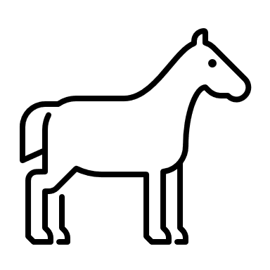

Index

Red Blood Cells
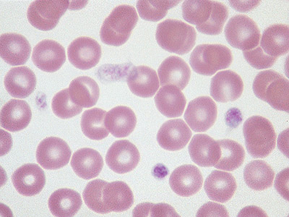
1
Figure 1 Canine Red Blood Cell

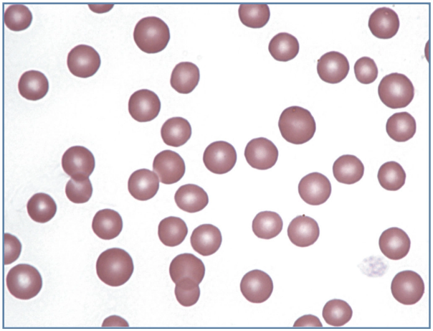
2
Figure 2 Feline Red Blood Cell

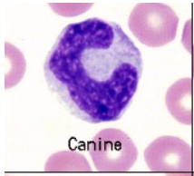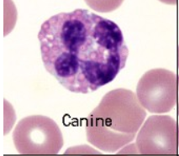
3
Figure 3 Canine Monocyte Figure 4 Canine Eosinophil
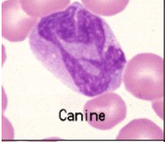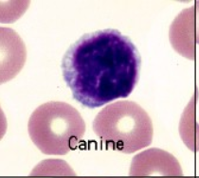
Figure 5 Canine Basophil Figure 6 Canine Lymphocyte

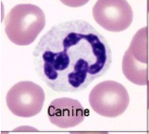
Figure 7 Canine Neutrophil
Different types of blood cells
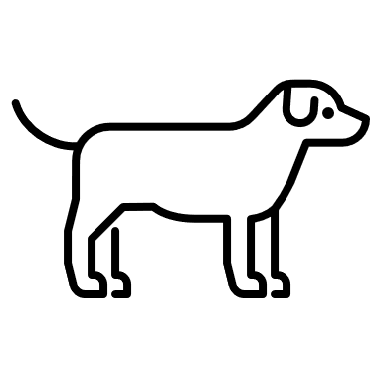

Erythrocytes: The canine erythrocyte in health is a relatively large, uniform, biconcave disc. This is reflected in the Wright’s stained blood film as a cell with an area of central pallor. ⁽³⁾
Neutrophils: Neutrophils are the predominant circulating WBCS in dogs, cats, and horses. Mature neutrophils, called segmented neutrophils, are about 12 µm in diameter and are characterized by a segmented nucleus that often has three to five lobes. ⁽⁴⁾
Eosinophils: In general, nuclei of mature eosinophils are shorter and less segmented than neutrophil nuclei and the cytoplasm, if visible, is pale blue. Marked variation in granule size, number and shape occurs within and between individuals of any breed. A specific and predictable morphologic variant of the eosinophil is seen in Greyhounds, other sighthounds (eg, Whippets, Deerhounds) and in some Golden Retrievers. ⁽³⁾
Basophils: Canine basophils are difficult to recognize since many do not have readily apparent granules. This is because the granules are a pale lavender versus purple. The major identifying features of canine basophils are the long and folded nucleus, described as “ribbon-like”, and the unusual gray to lavender hue of the cytoplasm. ⁽³⁾
Lymphocytes: Most of the lymphocytes that circulate in healthy dogs, cats, camelids and horses are small (mature) cells that have round nuclei with smooth, dense chromatin and a small rim of light blue cytoplasm. ⁽³⁾
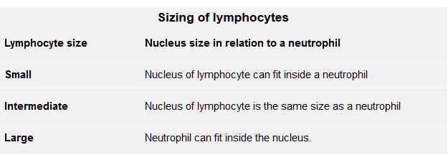₍₃₎
Monocytes: They are often larger than neutrophils and are usually the largest leukocyte, but there are no consistent species differences. The nucleus can be round to kidney-shaped to pseudo-lobulated (can mimic a neutrophil). It can even occasionally be band-shaped, especially in dogs, and may be confused with band neutrophils. However, the chromatin of monocytes is less dense than neutrophils, and is described as lacey to slightly clumped. ⁽³⁾

3
Figure 8 Canine Platelets
Platelets: Canine platelets are moderately variable in size; platelet granules are well-stained. This field is a good representation of the “red cell area” of the smear. It is in this area that the estimate of platelet numbers should be made. ⁽³⁾

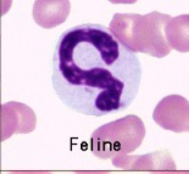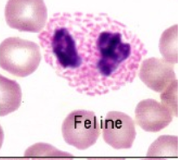
3
Figure 9 Neutrophil Figure 10 Eosinophil
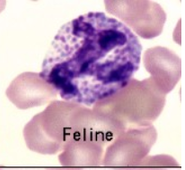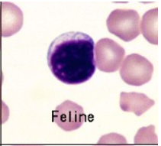
Figure 11 Basophil Figure 12 Lymphocyte
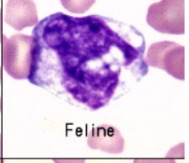
Figure 13 Monocyte

Different Types of the Blood Cells
Erythrocytes: Feline erythrocytes are smaller and more variable in size and shape than those of dogs. They have little to no central pallor as normally seen in routine blood films. ⁽³⁾
Neutrophils: Feline neutrophils have cytoplasm that is white and lacks visible granules. They may contain 1-3 small rod or round blue granules in their cytoplasm. ⁽³⁾
Eosinophils: Feline eosinophils contain granules that are small, rod-shaped, and numerous. ⁽⁵⁾
Basophils: Feline basophils are packed with small, slightly oval granules that are pale lavender rather than deep purple. The nucleus in many appears to have vacuoles, which are actually granules lying on top of the chromatin. Basophils are rare in blood of healthy cats. ⁽³⁾
Lymphocytes: Small lymphocytes are approximately 7-9 µm in diameter in dogs and cats, and they have slightly indented nuclei. The chromatin is coarsely clumped, and the cytoplasm is light blue and quite scanty. ⁽⁵⁾

Monocytes: They are often larger than neutrophils and are usually the largest leukocyte, but there are no consistent species differences. ⁽³⁾
Platelets: Cat platelets tend to vary more in size than dogs, with many large platelets being seen in blood from non-diseased or healthy cats. Platelets are also readily activated on blood sample collection in cats and clump frequently, precluding accurate platelet counts in many individuals of this species. ⁽³⁾
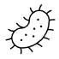
(Ab)normal Red Blood Cell Morphology
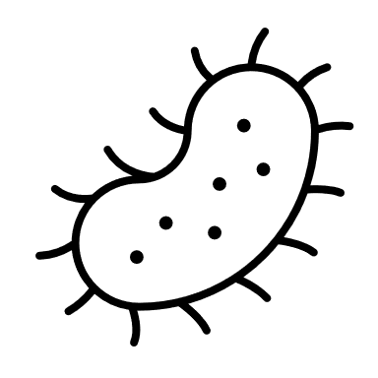Poikilocyte - a generic or umbrella term to describe erythrocytes with abnormal shape. 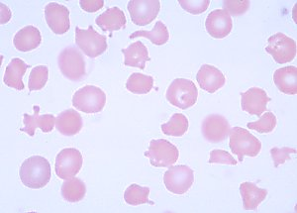 (13)
Acanthoycytes - Acanthocytes (or spur cells) are spherical cells with blunt-tipped or club-shaped spicules of different lengths projecting from their surface at irregular intervals. ⁽³⁾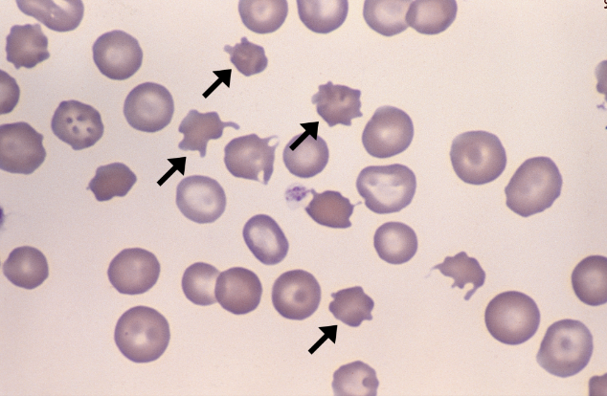
6
Rouleaux – The grouping of erythrocytes in stacks, increased rouleaux formation is seen with increased fibrinogen or globulin concentrations. ⁽⁵⁾
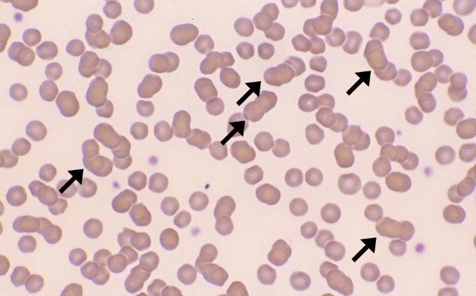
7
Autoagglutination – This occurs in immune-mediated disorders in which antibody coats the erythrocytes, resulting in the bridging and clumping of RBCs. Add a drop of saline to a drop of blood and examine the sample microscopically for autoagglutination. Rouleaux will disperse with saline. ⁽⁵⁾
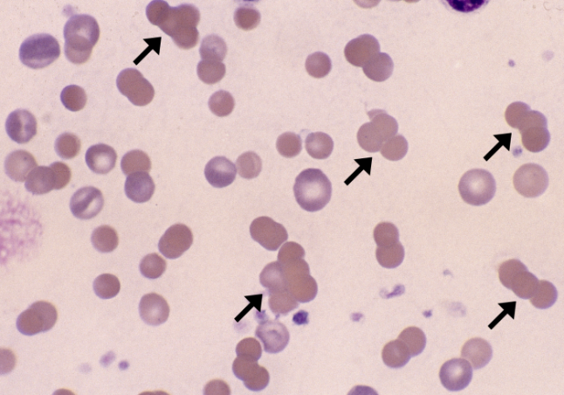
8
Polychromasia – Erythrocytes that exhibit a bluish tint when stained with Romanowsky stain. The blue tint is a result of the presence of organelles that remain within the cytoplasm. ⁽⁵⁾ 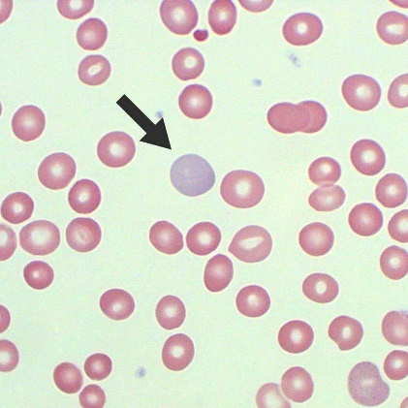
9
Hypochromasia – A decreased staining intensity that is caused by an insufficient amount of hemoglobin within the cell. ⁽⁵⁾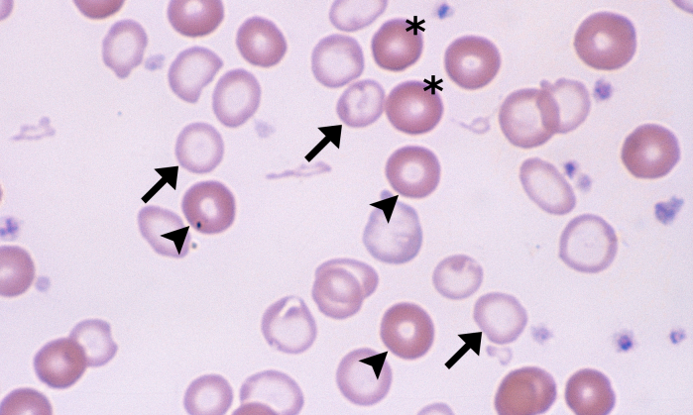
14

Hyperchromatophilic – Cells that appear to be more darkly stained than normal cells. ⁽⁵⁾
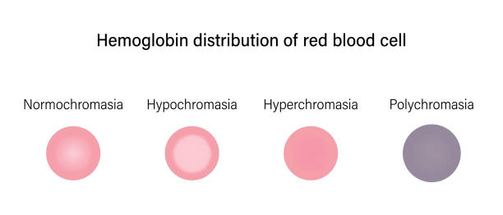⁽¹⁰⁾

Schistocytes – Are RBC fragments, are usually formed as a result of the shearing of the RBC via intravascular trauma. ⁽⁵⁾
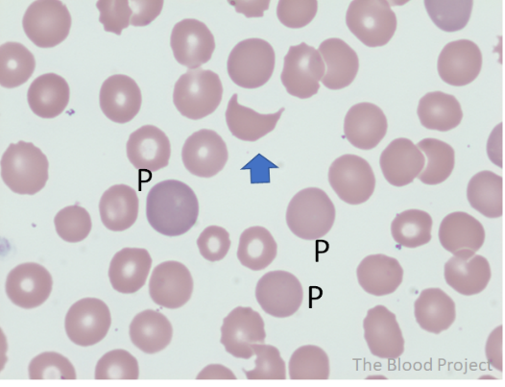
11
Echinocytes – Also called blurr cells, are spiculated cells with numerous short, evenly placed, bunt to sharp surface projections of uniform size and shape. ⁽⁵⁾
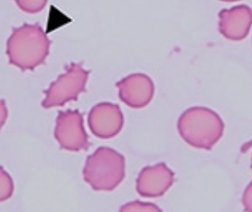
12
Drepanocytes – Also called sickle cells, are observed in the blood of normal deer and angora goats. ⁽⁵⁾
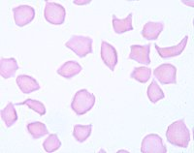 ⁽¹³⁾
Keratocytes – Commonly referred to as helmet cells, blister cells, or bite cells. This cell may appear to contain a vacuole. ⁽⁵⁾
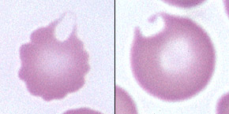 ⁽¹³⁾
Spherocytes – Darkly staining RBCs with reduced or no central pallor. Spherocytes are not easily detected in species other than dogs. ⁽⁵⁾
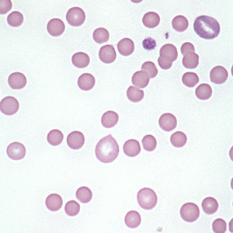 ⁽¹³⁾
Leptocytes (Target cells, codocytes) – These cells are characterized by an increased membrane surface area relative to cell volume, and the affected cells may take a variety of shapes. ⁽⁵⁾
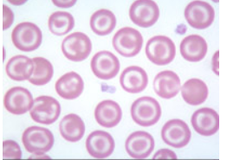⁽¹³⁾
Stomatocytes - erythrocytes with an elongated (mouth-like) area of central pallor. ⁽³⁾
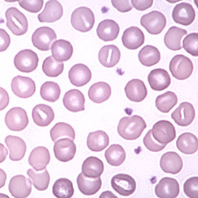 ₍₁₃₎
Elliptocytes - Elliptocytes are elongated red blood cells. There are three types: Type I is a slightly oval-shaped cell (used to be called ovalocyte), type II is a more rounded to oval shaped cell and type III is an elongate elliptical cell. ⁽¹³⁾
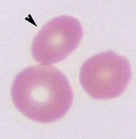 ⁽¹⁵⁾
Eccentrocytes - Eccentrocytes form under conditions of excess oxidant stress to the erythrocytes, which induces cross-linking of membrane proteins. ⁽¹³⁾
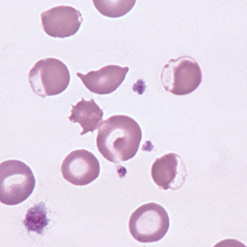 ⁽¹³⁾
Dacryocytes – Teardrop-shaped cells that are seen with myelofibrosis and certain other myeloproliferative diseases. ⁽⁵⁾
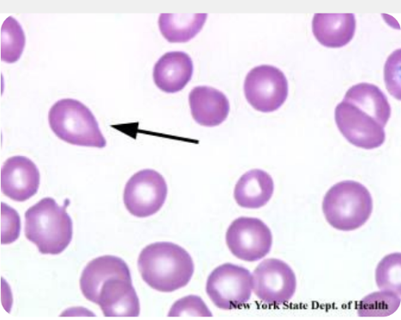 ⁽¹⁶⁾
Howell-Jolly Bodies – Basophilic nuclear remnants that are seen in young erythrocytes during the response to anemia. ⁽⁵⁾
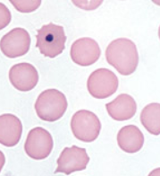 ⁽¹⁷⁾
Heinz Bodies – Round structures that represent denatured hemoglobin and that are caused by a certain oxidant drugs or chemicals. ⁽⁵⁾
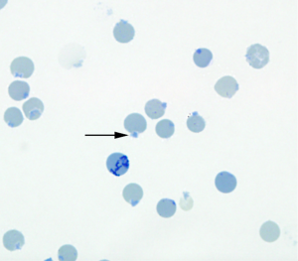 ⁽¹⁸⁾

Different types of Toxic Change
Left Shift - A left shift indicates the presence of immature neutrophils in blood and usually, but not always, indicates an inflammatory leukogram. A left shift can be due to release of bone marrow stores. This particularly occurs if the bone marrow reserve of mature neutrophils is low or depleted. ⁽²⁴⁾

Rouleaux – Increased fibrinogen or globulin concentrations. ⁽⁵⁾
Autoagglutimation – Occurs in immune-mediated disorders in which antibody coats the erythrocytes resulting in bridging and clumping of RBCs. ⁽⁵⁾
Schistocytes – May be observed with disseminated intravascular coagulopathy (DIC) when erythrocytes are broken by fibrin strands. Animals with DIC usually have concurrent thrombocytopenia ⁽⁵⁾
Acanthocytes – They are seen in patients with altered lipid metabolism. The presence of acanthocytes in middle-aged to old large breed dogs with concurrent regenerative anemia is suggestive of hemangiosarcoma. ⁽⁵⁾
Echinocytes – They have been seen with renal disease and lymphosarcoma in dogs; after exercise in horses; and in samples from normal, healthy pigs. ⁽⁵⁾
Drepanocytes – An in vitro phenomenon that is caused by high oxygen tension. ⁽⁵⁾
Keratocytes – The presence of keratocytes has been associated with hemangiosarcoma, neoplasia, glomerulonephritis, and various hepatic diseases. ⁽⁵⁾
Spherocytes – Spherocytes are significant in that they suggest the immune-mediated destruction of RBCs, resulting in hemolytic anemia. They may also be seen after transfusion with mismatched or improperly stored blood. ⁽⁵⁾
Leptocytes (target cells, codocytes)– A few may be seen in normal blood smears, and they may also be associated with anemia, liver diseases, and some inherited diseases. ⁽⁵⁾
Stomatocytes – These are considered artifacts if the areas of pallor are all perpendicular to the feathered edge. ⁽⁵⁾
Elliptocytes (Ovalocytes) – In some species these cells are associated with lymphoblastic leukemia, hepatic lipidosis, portosystemic shunts, and glomerulonephritis. ⁽⁵⁾
Eccentrocytes – Eccentrocytes have been described in patients with diabetic ketoacidosis or neoplasia, with Babesia canis infections, and after ingestions of oxidants such as garlic, onions, and acetaminophen. ⁽⁵⁾
Dacryocytes – These cells are seen with myelofibrosis and certain other myeloproliferative diseases. They have also been identified in the blood from llamas and alpacas that are iron deficient. ⁽⁵⁾
Howell-Jolly Bodies – Increased numbers may be seen after removal of the spleen or with splenic disorders. ⁽⁵⁾
Döhle bodies: These are pale round to linear blue aggregates in the cytoplasm, caused by whorls of rough endoplasmic reticulum. This is often the earliest and first indication of toxic change. However, note that healthy cats can have low numbers of small Döhle bodies and we have observed that Döhle bodies form in neutrophils with storage ⁽²³⁾
Heinz Bodies – Heinz bodies are often increased in concentration with diseases such as lymphosarcoma, hyperthyroidism, and diabetes mellitus in cats. ⁽⁵⁾

Large Animal Blood Cells
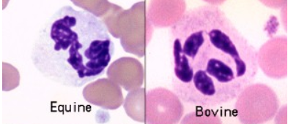
3
Figure 14 Neutrophil
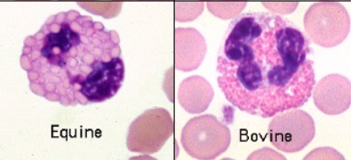
3
Figure 15 Eosinophil
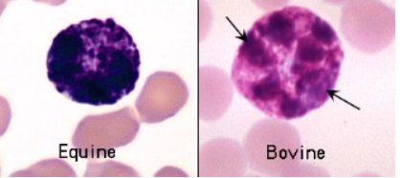
3
Figure 16 Basophil
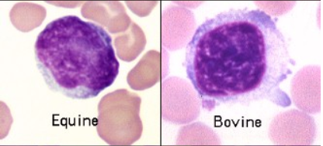
3
Figure 17 Lymphocyte
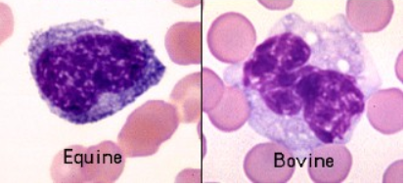
3
Figure 18 Monocyte
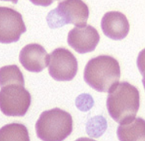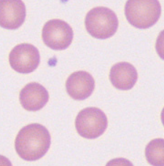
19
19
Figure 19 Equine Red Blood Cell Figure 20 Bovine Red blood cell
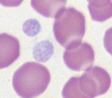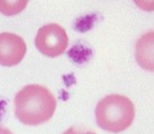
18
18
Figure 21 Equine Platelet Figure 22 Bovine Platelet

Different Types of Blood Cells
Neutrophils:
Equine neutrophils have white or slightly pink cytoplasm with no visible granules. The nuclei of equine neutrophils typically are long, thin and “knobby” with clumps of condensed chromatin projecting from the sides; they may not have classic segmentation. ⁽³⁾
Ruminant neutrophils have white cytoplasm with small pink granules; these impart an overall pink tint compared to the other species. ⁽³⁾
Eosinophils:
Horses have very large globular orange granules. ⁽³⁾
Ruminant and camelid eosinophils have many small very round orange granules. ⁽³⁾

Basophils:
Equine, bovine and camelid basophils have bright purple granules like mast cell granules. ⁽³⁾
Lymphocytes:
The lymphocytes in the horse and cow are more intermediate in size with lighter chromatin but still clumped chromatin (heterochromatin) and more irregular nuclear outlines (in the horse, at least). ⁽³⁾
The bovine lymphocyte also has increased amounts of light blue cytoplasm (a variant of normal, not a reactive cell). These lymphocytes often dominate in the blood of cattle. ⁽³⁾
Monocytes:
Monocytes are the leukocyte that is the most problematic for identification, because they can be fairly variable in size and appearance. They are often larger than neutrophils and are usually the largest leukocyte, but there are no consistent species differences. ⁽³⁾
Equine erythrocytes are of similar size as feline erythrocytes and also lack central pallor. Therefore, identification of spherocytic shape change is very difficult to discern in these species. Blood from healthy horses often display prominent rouleaux formation. ⁽¹⁴⁾
Bovine erythrocytes are similar in size to horse erythrocytes and have a small amount of central pallor (with some lacking central pallor). Some degree of anisocytosis can be seen in smears from healthy cattle. Cattle rarely display rouleaux formation in health or disease. ⁽¹⁴⁾
Equine platelets tend to be rather uniform in size and shape. The platelet granules stain very lightly with routine hematology stains, making the platelets faint and sometimes difficult to see at lower magnifications. Platelet counts in horses are often lower than in other species. ⁽¹⁸⁾
Bovine platelets are moderately variable in size with granules that are numerous and intensely-stained. Platelet counts tend to be high in health, especially in calves where counts in the neighborhood of one million/µL are common. ⁽¹⁸⁾

Exotic & Avian Blood Cells
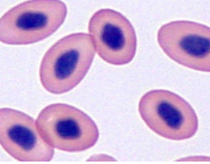
20
Figure 23 Avian Heterophil
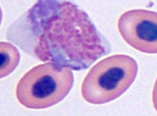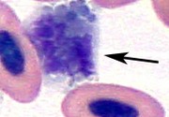
20
20
Figure 24 Avian Monocyte Figure 25 Avian Eosinophil
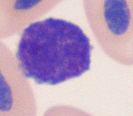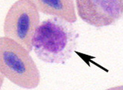
20
20
Figure 26 Avian Lymphocyte Figure 27 Avian Basophil
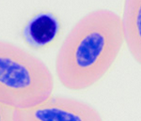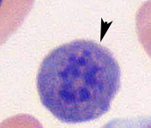
21
20
Figure 28 Avian Thrombocyte Figure 29 Immature Avian RBC
Avian erythrocytes are larger than mammals but smaller than reptiles with lower hemoglobin due to nucleated red blood cells. Avians have a different respiratory system that lets them transport oxygen efficiently without needing enucleated blood cells. ₍₅₆₎
Heterophils are the most abundant type of granulocytes in healthy birds. The cytoplasm will appear colorless and have eosinophilic granules. ₍₅₆₎
Eosinophils are the same size (or sometimes larger) than heterophils. They have round, strongly eosinophilic cytoplasmic granules and the granules stain more intensely than the heterophils. However, eosinophils will vary in different species of birds. ₍₅₆₎Basophils have deeply metochromatic granules and these granules will hide the nucleus. These cells are most often found in the peripheral blood. ₍₅₆₎
Lymphocytes in birds are similar to what we see in mammals. They are round cells with slightly indented, centrally positioned nucleus. The cytoplasm usually appears a light blue. ₍₅₆₎
Monocytes are the largest white blood cell and have the same appearance as those seen in mammals. They have abundant blue-gray cytoplasm and contain vacuoles or fine dust. ₍₅₆₎
Thrombocytes (platelets) tend to be nucleated cells with a round to oval like nucleus. The nucleus contains densely clumped chromatin and a colorless to pale gray cytoplasm. ₍₅₆₎

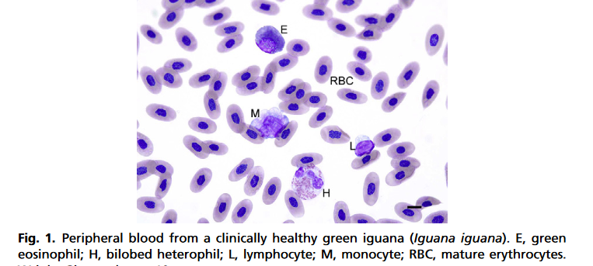
22
Figure 30 Reptile Blood
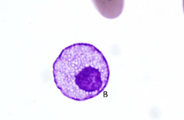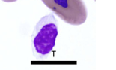
22
Figure 31 Reptile Basophil Figure 32 Reptile Thrombocyte
Erythrocytes are usually larger than those seen in mammals and birds. They have an oval to round nuclei with a dense purple chromatin and cytoplasm will stain orange-pink. ₍₅₆₎
Heterophils are round with eosinophilic granules and have a colorless cytoplasm that contains densely clumped chromatin. ₍₅₆₎
Eosinophils are large round cells with a centrally located nucleus that is either round or oval shaped. In some species the stain will cause granules to stain blue and they will vary in size from species to species. ₍₅₆₎
Basophils are small round cells that contain a metachromatic granules that often hides the nucleus. Size will vary between species. ₍₅₆₎
Lymphocytes are the same as what we seen in birds and mammals. They are round cells with a round or slightly indented nucleus and nuclear chromatin is heavily clumped. ₍₅₆₎
Monocytes are the largest white blood cell and vary in shape from round to ameboid. They cytoplasm will stain blue-gray and they contain many vacuoles or dust like particles. ₍₅₆₎
Thrombocytes are elliptical nucleated cells that has a purple staining nucleus. Cytoplasm is usually colorless and has very small granules. ₍₅₆₎
Math Formulas ⁽⁵⁶⁾

Mean Corpuscular Volume (MCV) –
PCV x 10 ÷ RBCs (units fl)
Mean Corpuscular Hemoglobin (MCH) –
HgB x 10 ÷ RBCs (units pg)
Mean Corpuscular Hemoglobin Concentrations
(Hgb÷PCV)x100 (units g/dL)
HgB =PCV÷3 (units g/dL)
PCV = Hgb X 3 (units %)
RBC Est. = PCV ÷ 6 x 1,000,000 (units est. RCB/uL)
WBC Est. = count 10 fields, take average, then multiply by 2,000 (units est. WBC/uL)
Platelet Est. = count 10 fields, take the average, multiply by 15,000. (units est. platelet/uL)
Reticulocyte Estimate = Examine on 40x. Count 10 fields. Avg. 200 RBCs per field (= 2,000)add up reticulocytes, divide by 20. (units %)
Reticulocyte Count = Count 1,000 RBCS while on oil, when you reach 1,000 stop. Take total number of reticulocytes and divide by 10. (units %)
Absolute Retics = Convert your reticulocyte (%) to a decimal (move decimal to the left two places) then multiply by the RBC count (units # of cell/reticulocytes/ul)
Corrected WBC = 100 WBC x WBC count
100 + NRBC
56

What is a hemocytometer? ⁽²⁵⁾
A hemocytometer is a specialized slide used for cell counting with a microscope. There are several types of hemocytometer, all with different counting grids. The most commonly used is the ‘Improved Neubauer’ chamber.
The Improved Neubauer has an H-shaped indent at the center of the slide that separates the space into two counting chambers. Grids are engraved onto the surface to make cell counting easier and more precise.
How to Use the Hemocytometer
- Clean the hemocytometer and the cover glass with ethanol. Ensure the ethanol evaporates completely so it does not affect your cells.
- Place the cover glass on top of the hemocytometer’s chambers to stop your sample from evaporating.
- Load 10 µl of your stained sample into one or both counting chambers with a micropipette. Capillary action ensures even distribution of the suspension within the chamber.
- Place the hemocytometer under the microscope.
- Adjust the microscope’s focus until you can clearly see the cells.
- Count the cells using a tally counter Keep track of both the total number of cells and the number of dead cells.
- When you are finished, clean the hemocytometer and the cover glass with ethanol.
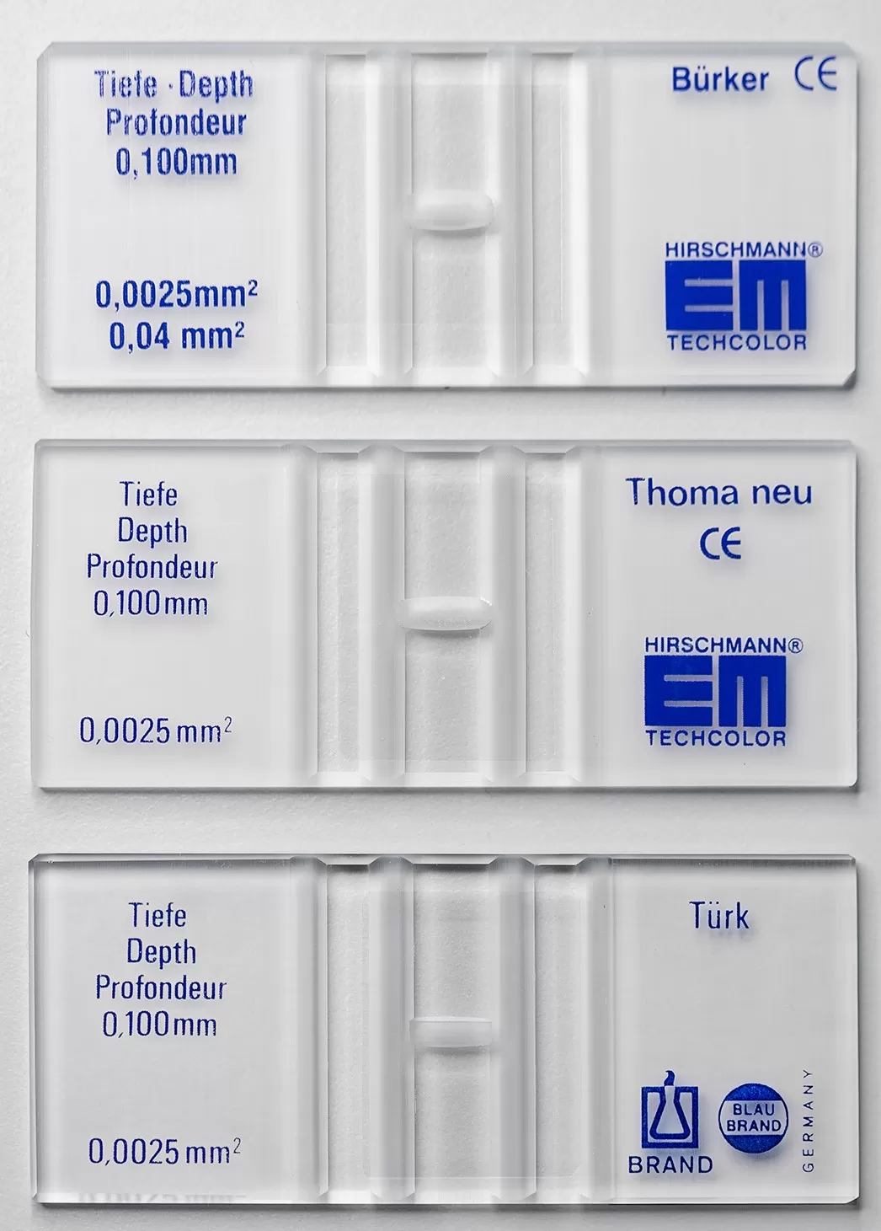 ⁽²⁵⁾
Figure 33 Hemocytometers
Hemocytometer Continued ⁽²⁵⁾
Before you start counting, you need to decide which squares of the hemocytometer counting grid you will count. It’s important to choose squares that give a good overall representation of the cells on the slide.
For example, avoid only counting cells in the top three squares of the grid as this may not be representative if the liquid did not spread evenly throughout the slide surface when dispensed from the pipette.
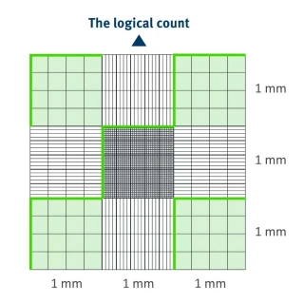
A common and representative approach is to count the cells in the four corner squares and the middle square of the hemocytometer’s grid. This is called a ‘logical count.’
Rules about which cells are counted as inside a square help ensure that you don’t count the same cell twice. Some labs include the cells that touch the top and right grid borders while excluding cells that touch the bottom and the left grid border. ⁽²⁵⁾

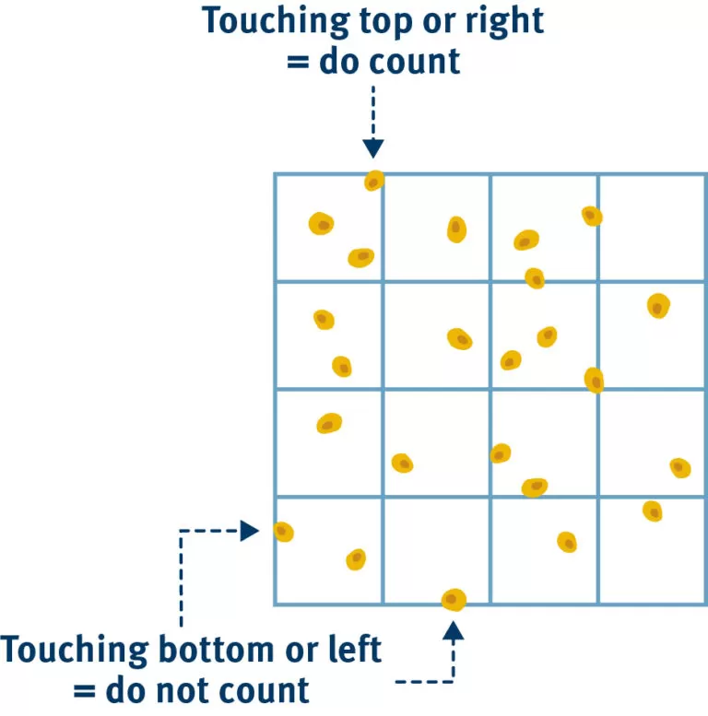

₍₂₅₎
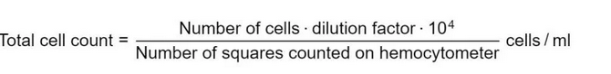⁽²⁵⁾
Different Types of Blood tests
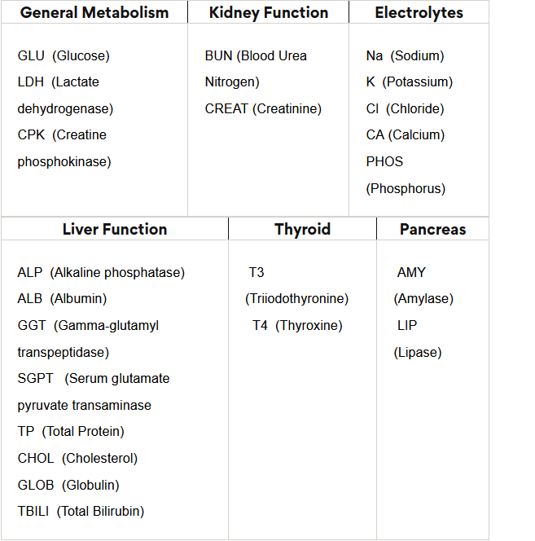⁽²⁶⁾
The Main Electrolytes:
Sodium (Na) – Plays a major role in the pH regulation of urine and acid-base balances. Hypernatremia (water deprivation, hyperventilation, osmotic diuresis) refers to elevated blood levels of sodium while hyponatremia (GI disorders, Ketonuria, CHF)is decreased blood level of sodium. ⁽⁵⁾
Potassium (K) – This electrolyte is important for normal muscular function, respiration, cardiac function, nerve impulse transmission, and carbohydrate metabolism. Elevated potassium can cause hyperkalemia (metabolic acidosis, renal insufficiency, urinary tract obstruction). Decreased levels of potassium can cause hypokalemia (anorexia, ketonuria, diuresis). ⁽⁵⁾
Chloride (Cl) – Chloride is important for maintenance of water distribution, osmotic pressure, and the normal cation/anion ratio. ⁽⁵⁾
Magnesium (Mg) – This electrolyte is found in all body tissues and more than 50% is found in the bones. Mg activates enzyme systems and is involved in the production and decomposition of acetylcholine. Cattle and sheep are the only domestic animals that show clinical signs related to magnesium deficiencies. ⁽⁵⁾
Calcium (Ca) – More than 99% of calcium in the body is found in the bones. The remaining 1% (or less) functions to maintain neuromuscular excitability and tone, the maintenance of activity for various enzymes, blood coagulation and more. Ca concentrations are usually inversely related with inorganic phosphorus concentrations, meaning if calcium concentrations rise phosphorus concentrations will fall. ⁽⁵⁾
Phosphorus – 80% of phosphorus is found in the bones while the other 20% functions as energy storage, release, transfer, involvement in carbohydrate metabolism, and composition of nucleic acids and phospholipids. ⁽⁵⁾
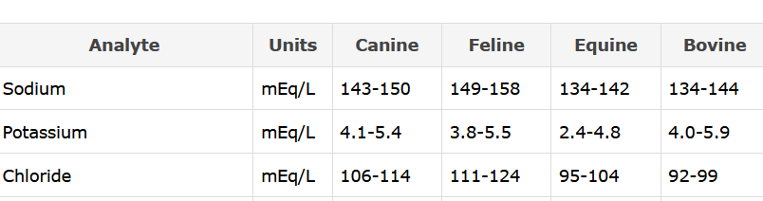
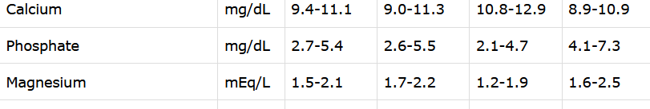⁽²⁷⁾
Normal Ranges for Dogs
26
- Glucose: 67 - 125 mg/dL
- ALT: 15 - 84 U/L
- Total Bilirubin: 0.0 - 0.4 mg/dL
- Total Protein: 5.2 - 7.8 gm/dL
- Urea Nitrogen: 9 - 27 mg/dL
- Phosphorus: 2.6 - 6.8 mg/dL
- Sodium: 140 - 153 mmol/L
- Chloride: 106 - 118 mmol/L
- LDH: 10 - 273 U/L
- Magnesium: 1.5 - 2.7 mg/dL
- Lipase: 200 - 700 U/L
- T4: 1.0 - 4.7 ug/dL

Normal Ranges for Cats

- Glucose: 70 -160 mg/dL
- ALT: 10 - 80 U/L
- Total Bilirubin: 0.0 - 0.2 mg/dL
- Total Protein: 5.6 - 7.7gm/dL
- Urea Nitrogen: 20 - 30 mg/dL
- Phosphorus: 2.7 - 7.6 mg/dL
- Sodium: 145 - 155 mmol/L
- Chloride: 117 - 124 mmol/L
- LDH: 79 - 380 U/L
- Magnesium: 1.7 - 2.9 mg/dL
- Lipase: 40 - 200 U/L / T4: 2.0 - 5.5 ug/dL
Blood Parasites 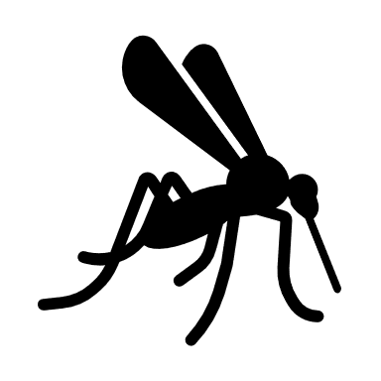

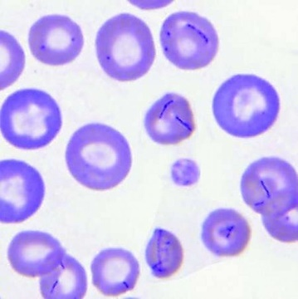
28
Figure 34 Mycoplasma haemocanis (formerly Haemobartonella canis)
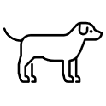Mycoplasma haeomocanis rarely causes anemia in dogs with normal spleens and normal immune systems. Clinical anemia can develop when a carrier dog is splenectomized or when a splenectomized dog is transfused with blood from a carrier donor. M. haemocanis may be a widespread latent infection in kennel-raised dogs. These dogs are commonly used for research worldwide and the potential exists for such chronic infections to confound research results obtained from these animals. ⁽²⁹⁾
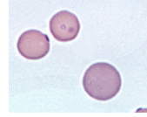
29
Figure 35 Mycoplasma haemofelis (formerly Haemobartonella felis)
Mycoplasma haemofelis (formerly Haemobartonella felis) is an epicellular bacterial parasite of feline erythrocytes that can cause hemolytic anemia. In blood smears stained with polychrome stains, the organisms are recognized as small blue cocci, rings, or rods on the edges or across the faces of red cells. ⁽²⁹⁾
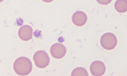
29
Figure 36 Mycoplasma wenyonii (formerly Eperythrozoon)
The clinical signs of Mycoplasma wenyonii are unusual, consisting of acute onset hindleg and scrotal (males) or udder (females) swelling. Cattle are febrile and cows have decreased milk production. It appears to be especially prevalent in post-partum heifers. In bulls, the parasite may cause decreased fertility due to testicular degeneration. The disease appears to be seasonal in summer to fall. ⁽²⁹⁾
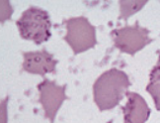
²⁹
Figure 37 Mycoplasma suis and Mycoplasma parvum
Mycoplasma suis and Mycoplasma parvum (formerly Eperythrozoon spp.) are uncultivated, wall-less bacteria of swine that parasitize the surface of erythrocytes. The presence of two distinct species in pigs was established by cross-inoculation studies. Furthermore, they differ in size (M. suis varies from 1 µm to 2.5 µm whereas M. parvum is smaller at 0.5 µm) and degree of parasitemia (with M. suis, many parasites are often observed, whereas with M. parvum, the parasitemia is low). ⁽²⁹⁾
Babesia
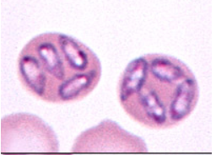
30
Figure 38 Babesia canis
Transmission is primarily by the brown dog tick (Rhipicephalus sp.). Infection can result in inapparent, mild or severe disease, depending to some extent on the pathogenicity of the infecting strain and the susceptibility of the host. Puppies are more likely to be severely affected than adult dogs. Mild disease is mainly an extravascular hemolytic anemia but severely affected dogs have signs of intravascular hemolysis (as the parasite lyses the red blood cell to complete its lifecycle) and may develop disseminated intravascular coagulation (DIC). ⁽³⁰⁾

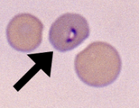
31
Figure 39 Babesia felis
Babesia felis is a rare parasite that can produce a regenerative anemia, lethargy and anorexia in cats. The parasite is very small and quite difficult to visualize. Affected cats can be icteric and hyperglobulinemic. ⁽³⁰⁾
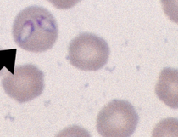
31
Figure 40 Theileria equi
Transmission occurs between horses with ticks, through fomites, common needle usage, and transplacentally. In experimental infections, clinical signs are usually apparent within 10-30 days. Clinical signs are usually not specific, consisting of fever, anorexia, depression, lethargy and peripheral edema. ⁽³⁰⁾
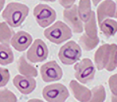
32
Figure 41 Babesia bigemina
Babesia bigemina (Texas cattle fever) and Babesia bovis (red water fever) affect cattle. B. bovis produces more severe disease and can cause red water fever in deer. They are transmitted by Boophilus ticks. They produce a hemolytic anemia, hemoglobinuria, fever, and anorexia. The hemoglobinuria in Babesiosis distinguishes the hemolytic anemia from Anaplasmosis, which is an extravascular hemolysis. Young calves < 7 months of age are often resistant to infection. ⁽³⁰⁾

Cytauxzoon

Cytauxzoon felis is an apicomplexan protozoal parasite that causes severe, and often fatal disease, in cats. The disease is transmitted by ticks and Bobcats have been identified as the reservoir host (and are usually asymptomatic), with the cat being considered a dead-end host. Transmission is primarily mediated by Amblyomma americanum (Lone Star) ticks. The organism undergoes sexual reproduction in the gastrointestinal system of the infected tick, which then deliver the organism as sporozoites into tissues of bitten cats.⁽³³⁾

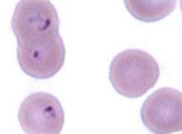
33
Figure 42 Cytauxzoon felis

Hemoproteus
34
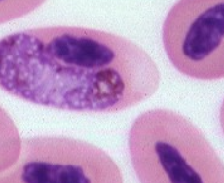
Figure 43 Hemoproteus
Hemoproteus is a commonly encountered and easily identified protozoan parasite that infects red blood cells in wild birds of many species. It is generally not associated with obvious clinical signs or evidence of hemolytic anemia (exceptions may occur in quail and pigeons). ⁽³⁴⁾

Leukocytozoon

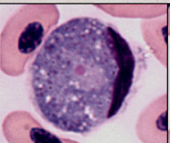
34
Figure 44 Leukocytozoon
Parasites of the genus Leukocytozoon infect both domestic fowl (ducks, geese) and wild birds of many species. In most instances, the infection is without obvious clinical signs, although young raptors, waterfowl, and turkeys may develop hemolytic anemia on occasion. Despite the name of the genus, it is now believed that the gametocytes seen in peripheral blood develop in erythrocytes rather than leukocytes. The extreme distortion of the host cell by the parasite, however, makes this difficult to appreciate. ⁽³⁴⁾

Plasmodium
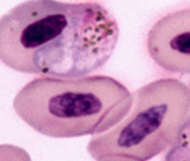
34
Figure 45 Plasmodium spp
Plasmodium spp. are protozoan parasites which occur in many species of birds and are the cause of avian malaria. Transmitted by mosquitoes, infection with Plasmodium can be a cause of hemolytic anemia in some species (canaries, penguins, poultry, ducks, pigeons and falcons). Plasmodium is very difficult to distinguish from Hemoproteus, since some species of Plasmodium can have similar halter-shaped gamonts to Hemoproteus and they both contain iron pigment. ⁽³⁴⁾

Anaplasma ⁽³⁵⁾

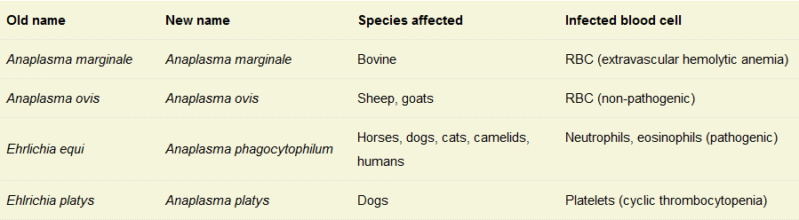
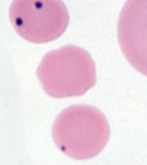
Figure 46 Anaplasma marginale
Anaplasma marginale is an intracellular erythroparasite of cattle that produces severe hemolytic anemia and is of major economic importance. Endemic areas in the U.S. are the south and southwest and some parts of California. The disease is transmitted by several species of ticks and is called tick-borne fever. After infection, there is an incubation period of several weeks followed by a period during which parasitemia increases rapidly and is quickly followed by precipitous drop in hematocrit. ⁽³⁵⁾
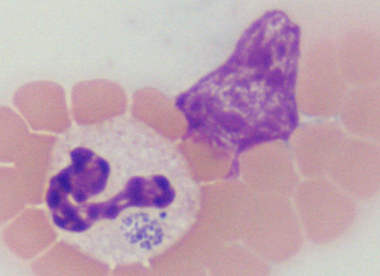
35
Figure 47 Anaplasma phagocytophilum
Vector: Ixodes sp (deer ticks).
Cells: Neutrophils, eosinophils. Morulae are frequently seen in neutrophils, although can degrade rapidly after institution of antimicrobial therapy (losing their characteristic grape-like features).
Clinical signs: Several syndromes
Bloodwork: Thrombocytopenia (characteristic), non-regenerative anemia, neutropenia (usually no left shift or toxic change).
Two main species of Anaplasma are thought to infect dogs – Anaplasma phagocytophilum (aka Ehrlichia equi) and Anaplasma platys. The former infects granulocytes (neutrophils and eosinophils) whereas the latter infects platelets. The organisms are transmitted by ticks, particularly Ixodes species, with rodents and deer serving as reservoir hosts (in the northeastern United States, white-footed mice are the implicated main reservoir of not only Anaplasma but also Borrelia burgdorferi). Transmission from the tick to an accidental host, like dogs, is thought to take 36-48 hours (so remove ticks as soon as you see them on yourself or your pets, particularly small brown “deer” ticks, which are Ixodes species). Tetracyclines are the treatment of choice for all Anaplasma infections. (35)
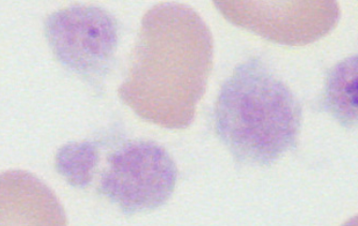
35
Figure 48 Anaplasma platys
• Vector: Unknown.
• Cells: Platelets. After experimental infection, morulae appear in platelets within 10-14 days, with maximal parasitemia 4 days later. The platelet count drops after this parasitemia and then there is a cyclical parasitemia and thrombocytopenia at 10-14 day intervals (similar to the cycles of anemia seen with Mycoplasma hemofelis infection in cats). The number of parasitized platelets decreases with each cycle, making the diagnosis more difficult over time. ⁽³⁵⁾

Ehrlichia

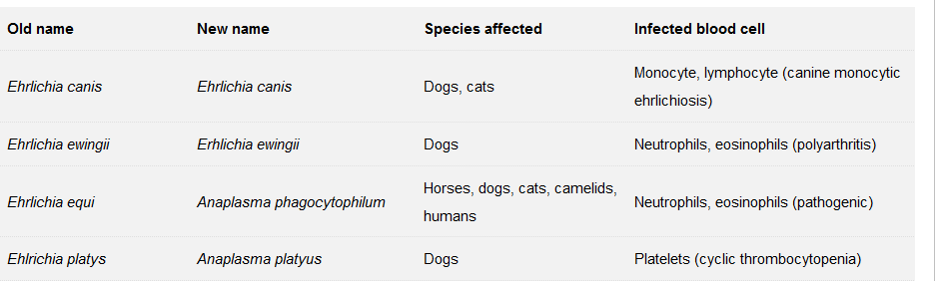
(36)

Ehrlichia canis
• Vector: Rhipicephalus sanguineus, Dermacenter variabilis.
• Cells: Monocytes, macrophages, lymphocytes. Morulae rarely seen in infected dogs and usually only in acute infection.
• Clinical signs: Fever, lethargy, anorexia, excess hemorrhage (attributed to platelet dysfunction as well as thrombocytopenia – thrombocytopenia is usually not severe enough to induce hemorrhage alone – platelet counts are usually moderately decreased, i.e. 50-150,000/uL). Some dogs have neurologic disease and may have increased numbers of granular lymphocytes in their cerebrospinal fluid (this finding is not specific for this organism).
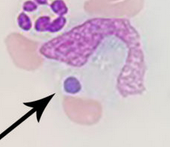
37
Figure 49 Ehrlichia canis

Ehrlichia ewingii
•Vector: Amblyomma americanum.
•Cells: Neutrophils, eosinophils. Morulae frequently seen in infected dogs, with numbers of infected cells corresponding to severity of infection. Morulae can also be seen in neutrophils within joint fluid, but may be only seen in <1% of cells in the fluid.
• Clinical signs: Fever, lethargy, anorexia, polyarthritis (the main differential diagnosis is Anaplasma phagocytophilum, which produces a similar disease). In one study of 41 dogs with natural infection, signs referable to arthritis (limb or joint pain) and fever were among the most commonly observed clinical signs, along with lymphadenopathy, and vomiting and diarrhea. Affected dogs had co-morbidities including heart murmurs (related to anemia in some dogs), renal disease, immune-mediated hemolytic anemia and cancer, to name a few. It is difficult to know whether the clinical signs were related to the bacterial infection or the comorbidities in the study. Rarely, infected dogs can lack obvious clinical signs. ⁽³⁷⁾

Dirofilaria immitis
Heartworm (HW) disease is caused by the filarial organism Dirofilaria immitis. At least 70 species of mosquitoes can serve as intermediate hosts; Aedes, Anopheles, and Culex are the most common genera acting as vectors. Patent infections are possible in numerous wild and companion animal species. In canids and other susceptible hosts, infective larvae (L₃) molt into a fourth stage (L₄) in 3–12 days. After remaining in the subcutaneous tissue, abdomen, and thorax for ~2 months, L₄ undergo their final molt at day 50–70 into young adults, arriving in the heart and pulmonary arteries ~70–120 days after initial infection. ⁽³⁸⁾
Infected cats may be asymptomatic or exhibit intermittent coughing, dyspnea, heart failure, vomiting, lethargy, anorexia, or weight loss. There is currently neither a satisfactory nor approved treatment approach for heartworm infection in cats; therefore, all cats in regions endemic for canine HW disease should receive drug prophylaxis. Infections are likely more often lethal in cats than dogs, though a percentage of cats are thought to survive infection without demonstrable clinical signs. ⁽³⁸⁾
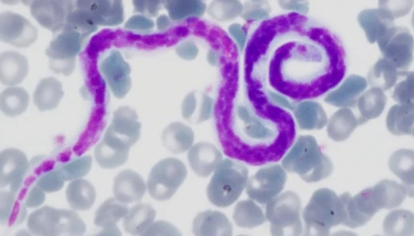
39
Figure 50 Heartworm
Dogs in the low-risk category would ideally fulfill the following conditions: young, with no clinical signs, normal thoracic radiographs, a low level of circulating antigen or a negative antigen test with circulating microfilariae, no worms visualized by echocardiography, no concurrent disease, and with owners capable of completely restricting exercise. ⁽³⁸⁾
Dogs at high risk of thromboembolic complications include those with signs related to HW infection (eg, coughing, dyspnea, ascites), abnormal thoracic radiographs, high level of circulating antigen, worms visualized by echocardiography, concurrent disease, and little or no possibility that the owners will restrict exercise. ⁽³⁸⁾

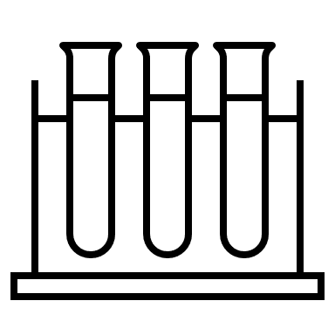 Urinalysis

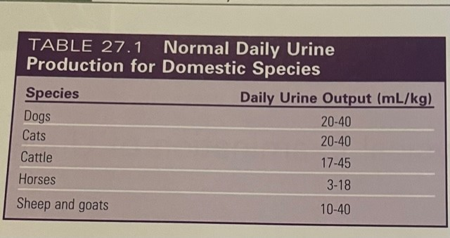
⁽⁵⁾

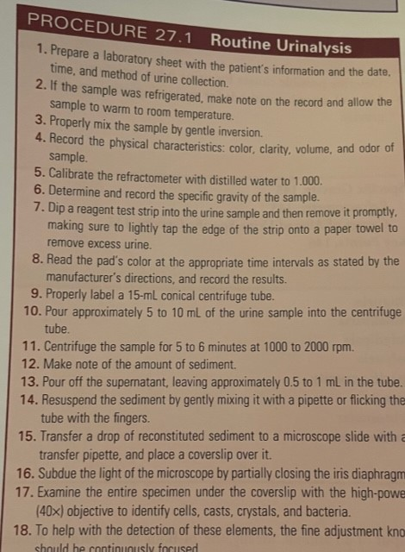(5)

Urine Dipstick ⁽⁴⁰⁾
pH - Knowledge of the urine pH is important in interpreting urine sediment findings. Erythrocytes, leukocytes, and casts tend to disintegrate in alkaline urine (pH > 8.0). In addition, precipitation of urine crystals in supersaturated urine is highly dependent on urine pH (e.g. struvite will precipitate in alkaline not acidic urine).
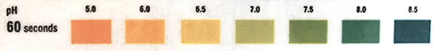
Protein - The presence of protein in the urine can yield clues as to the presence of glomerular barrier dysfunction (altered permeability) and proximal tubular disease. In fact, proteinuria can be an early marker of renal disease, even before the development of defects in urine concentrating ability or azotemia. However, this is disease dependent as some renal diseases, such as acute kidney injury, may not cause proteinuria at all.
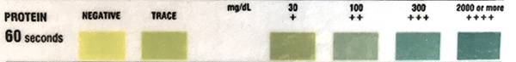
Glucose - Normal urinary glucose is usually below the level of sensitivity of dipstick techniques, although a few animals may have trace positive reactions on the dipstick and small amounts of glucose in the urine when measured on a chemistry analyzer. Therefore, glucose is usually an abnormal finding in urine (particularly when higher than trace).
(40)

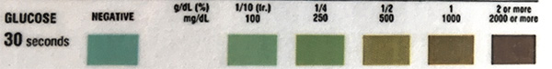
Ketones - Ketonuria indicates deranged energy metabolism, where fat is used instead of glucose for energy production. This usually occurs in states of negative energy balance, where energy intake does not meet demands. Fat metabolism can result in production of ketone bodies in amounts greater than can be metabolized by peripheral tissue; filtration into urine in excess of tubular reabsorption then results in ketonuria.
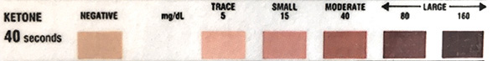
Bilirubin - Dogs have a low renal threshold for bilirubin, therefore highly concentrated urine samples from this species may have a trace to 1+ reaction. Male dogs can also conjugate bilirubin in their renal tubules (after uptake of unconjugated bilirubin from blood) so male dogs are more likely to have a bilirubinuria than female dogs. This may be clinically insignificant.
(40)
Heme - A positive reaction for heme on a dipstick occurs in the following situations:
Hemorrhage (hematuria): This is the most common cause of a positive reaction. The reaction for heme on the dipstick is very sensitive and will detect heme associated with as few as 10 RBC/uL.
Intravascular hemolysis (hemoglobinuria)
Skeletal muscle injury (myoglobinuria)
False positive reaction due to non-heme peroxidases: Bacterial peroxidases, chemicals with peroxidase activity (e.g. bleach).
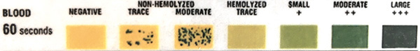

Uric Acid - Uric acid is usually converted by hepatic uricase to allantoin, which is excreted in the urine of most dog breeds, except the Dalmation. The Dalmation has a defect in a putative uric acid transporter, SLC2A9, which results in decreased uric acid uptake into hepatocytes and decreased conversion to allantoin. ⁽⁴⁰⁾

Urobilinogen - Decreased urobilinogen (urobilin) is seen with cholestasis (does not enter the intestine to be produced) or dysbiosis (decreased produced in intestine), whereas high values can be seen in liver disease (decreased uptake or cycling) and hemolytic anemia (increased production and excretion of conjugated bilirubin into the intestine, if there is no concurrent cholestasis). In general, this test is not considered diagnostically useful in animals. ⁽⁴⁰⁾

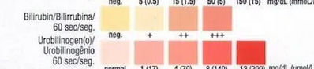
⁽⁴¹⁾

Sediment in urine ⁽⁴³⁾
White Blood Cells - White blood cells (WBC) are reported semi-quantitatively as the number seen per high power field (HPF) using the high dry objective (40x). Less than 5 WBC/HPF is commonly accepted as normal (however, it is unclear on where this number was derived from and in a clean urine [e.g. minimal hematuria, cystocentesis collection, <5 WBC/HPF could very well be abnormal). Greater numbers (pyuria) generally indicate the presence of an inflammatory process somewhere along the course of the urinary tract (or urogenital tract in voided specimens).
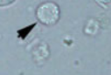
Figure 51 White Blood Cell
Red Blood Cells - Red blood cells (RBC) are reported semi-quantitatively as number seen per high power field (HPF). Increased red blood cells in urine is termed hematuria, which can be due to hemorrhage (e.g. idiopathic renal hematuria in young large breed dogs, hemorrhagic cystitis in horses or hemorrhage due to inflammation, necrosis, trauma, or neoplasia somewhere along the urinary tract (or urogenital tract in voided specimens). The hemorrhage can originate from anywhere in the urinary tract, as well as the genital tract (in voided or catheterized specimens).
43
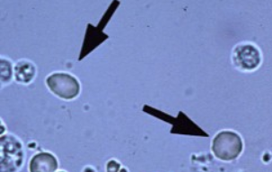
Figure 52 Canine RBC in fresh urine
Epithelial Cells - Epithelial cells are subjectively semi-quantified in urine (usually under low power using the 10x objective) as: none seen, few, moderate, many. It is difficult to distinguish small transitional epithelial cells from WBCs and renal tubular epithelial cells from transitional epithelial cells. Thus, all non-squamous cells in urine are considered to be of transitional origin.
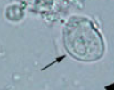
43
Figure 53 Epithelial Cells
Transitional Epithelial Cells - The urinary tract from the pelvis down the ureters to the bladder and the proximal urethra is lined by transitional epithelial cells. These cells vary in size and shape depending on the location from which they originate, e.g. those from the renal pelvis are more caudate whereas those from the bladder are more round to polygonal and vary in size. These cells naturally slough into the urine in quite low numbers, so none to a few transitional epithelial cells are seen in the urine from healthy animals.
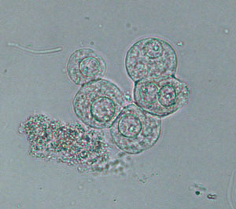
42
Figure 54 Transitional Epithelial Cell

Squamous Epithelial Cell - Squamous cells are frequently seen as contaminants in voided urine samples and can also contaminate samples collected by catheterization. Urine collected by cystocentesis should not contain any squamous epithelial cells. They are larger than transitional cells and have small central nuclei. They can be round or have one or more flat border. Keratinized squamous epithelial cells are from the the skin or vulva and are large cells with angular borders. They may or may not have nuclei (see image to the right). Nuclei are more visible in cells when the urine is stained with Sedi-stain (see lower panel of second image on the right).
43
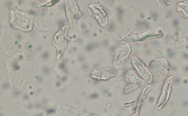
Figure 55 Squamous Epithelial Cells
Renal tubular epithelial cells – Renal tubular epithelial cells are rarely seen in the urine and, as mentioned above, are very difficult to distinguish from transitional epithelial cells. If large numbers of smaller epithelial cells of uniform appearance (size and shape) are observed in the urine, a renal origin for these cells is suspected.
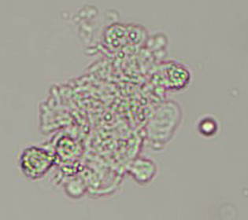
Figure 56 Renal Epithelial Cells

Sperm - Sperm in urine generally are of significance only as a testament to the intact maleness of the donor. They may be seen in urine from males collected by voiding, catheterization, or cystocentesis. Rarely, they may be observed in voided urine from a recently-bred female. The presence of sperm is reported as part of the complete sediment examination, the goal of which is to report all microscopic findings.
43
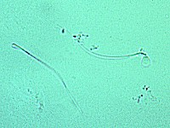
Figure 57 Sperm

Yeast - Yeasts in unstained urine sediments are round to oval in shape, colorless, and may have obvious budding. They often represent contaminants, and are especially suspect if the sample is voided and/or old. In other circumstances, however, their significance should not be discounted. ⁽⁴⁹⁾
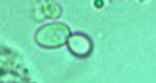
49
Figure 58 Budding Yeast
Cocci - Bacterial cocci are readily identified when they form long chains (likely Streptococcus spp.). However, doublets and clusters must be distinguished from small amorphous crystals, cellular debris, and small fat droplets, all of which show brownian motion in urine. A Gram-stained smear of urine sediment could be done to confirm the presence of cocci and distinguish them from non-bacterial structures.
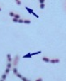
Figure 59 Cocci
Bacilli - Bacteria can be identified in unstained urine sediments when present in sufficient numbers by their characteristic rod shapes. This is more readily done for bacilli than cocci, which can mimic other structures.
49
Bacteria are not seen in normal urine (which is sterile). Their presence could indicate an infection (particularly if in large numbers, of a uniform type or accompanied by pyuria) or contamination (more likely in voided samples).
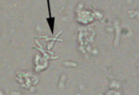
Figure 60 Bacilli
Capillaria plica - Capillaria eggs must be differentiated from Trichuris (whipworm) eggs, the latter of which may be seen with fecal contamination of the urine. If the ova were seen in a well- handled urine collected by cystocentesis, fecal contamination could be ruled out.
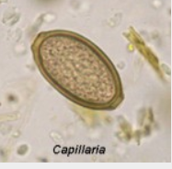
Figure 61 Capillaria
Dioctophyma renale - the giant kidney worm, has large, yellow-brown, thick-walled ova with a characteristic wavy surface (not pictured). Eggs may be seen in urine if a gravid female worm is present. Though endemic in areas of Canada, the infection is very rare in the United States. ⁽⁴⁹⁾
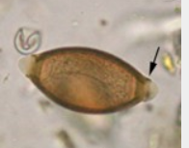
49
Figure 62 Dioctophyma renale
Crystals
Struvite - Struvite crystals (magnesium ammonium phosphate, triple phosphate) usually appear as colorless, three-dimensional, prism-like crystals (“coffin lids”). Occasionally, they instead resemble (vaguely) an old-fashioned double-edged razor blade (lower frame). They are usually large and can be readily observed at low magnification (however, confirmation of crystal identity should always be performed under high magnification). Struvite crystals are the most common type in urine from dogs and cats.
43
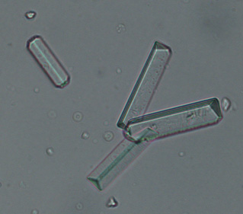
Figure 63 Struvite Crystals
Bilirubin - Bilirubin crystals form from conjugated bilirubin (water soluble) and are needle-like to granular crystals that are yellow in color. They tend to precipitate onto other formed elements in the urine. In dogs, they often are of no clinical significance (healthy dogs can have low, but detectable, bilirubin levels in urine). Bilirubin crystals (or a positive chemical reaction on the urine dipstick) in feline, equine, bovine, or camelid urine is an abnormal finding and the animal should be investigated for an underlying cholestatic process.
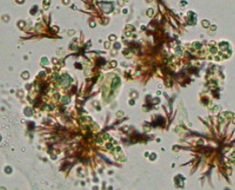
43
Figure 64 Bilirubin Crystals
Calcium Carbonate - Calcium carbonate crystals are variably sized crystals that frequently appear as large spheroids with radial striations. They can also be seen as smaller crystals with round to ovoid shapes. These crystals are common in the urine of normal horses, rabbits, guinea pigs and goats. They have not been observed in canine or feline urine.
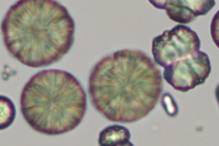
Figure 65 Calcium Carbonate

Amorphous Crystals - “Amorphous” crystals appear as aggregates of finely granular material without any defining shape at the light microscopic level. Small amorphous crystals can be confused with bacterial cocci in some cases, but can be distinguished by gram-staining. Degenerating cells can also resemble “amorphous” crystals.
43
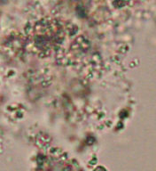
Figure 66 Amorphous Crystals
Calcium oxalate dihydrate - Calcium oxalate dihydrate crystals typically are colorless squares whose corners are connected by intersecting lines (resembling an envelope). These crystals are often seen in normal urine from domestic animals and can also be an artifact of storage (they can develop in stored urine), emphasizing the need to perform a urinalysis on fresh urine samples. They are birefringent with polarized light.

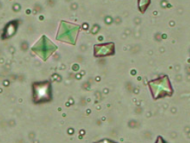
43
Figure 67 Calcium Oxalate Dihydrate
Calcium Oxalate Monohydrate - Calcium oxalate monohydrate crystals vary in size and may have a spindle, oval, or dumb-bell shape. These forms of calcium oxalate monohydrate indicate supersaturation of the urine with calcium and oxalate and, along with calcium oxalate dihydrate crystals (“square envelopes”), can be seen in the urine of animals that have no urologic problems or those suffering from oxalate urolithiasis, hypercalciuric or hyperoxaluric disorders, or rarely ethylene glycol toxicosis. They are infrequent in the urine of normal dogs and cats but can be seen in the urine from healthy horses.
44
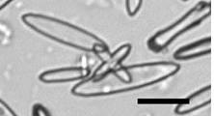
Figure 68 Calcium Oxalate Monohydrate
Ammonium Biurate - Ammonium urate (or biurate) crystals generally appear as brown or yellow-brown spherical bodies with irregular protrusions (“thorn-apples”). In some urine samples, they do not have irregular protrusions but have smooth borders and can resemble calcium carbonate (although these do not occur in the urine from dogs and cats). They have been seen in animals on chemotherapy with increased uric acid production. They can be seen in urine from normal Dalmatians, English Bulldogs and Black Russian terriers, due to a defect in a putative urate transporter.
43
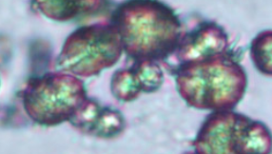
Figure 69 Ammonium Biurate
Cystine - Cystine crystals are flat colorless plates and have a characteristic hexagonal shape with equal or unequal sides. Cystine crystalluria or urolithiasis is an indication of cystinuria, which is an inborn error of metabolism involving defective renal tubular reabsorption of certain amino acids including cystine. Sex-linked inheritance is suspected since male dogs are almost exclusively affected. Many breeds, as well as mongrels, have been reported affected. Renal function otherwise appears to be normal and, aside from a tendency to form uroliths, the defect is without serious consequence.
43
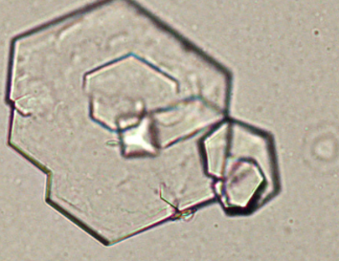
Figure 70 Cystine
Leucine & Tyrosine: Leucine are round to oval yellowish-brown crystals with circular striations on their edges (given them a somewhat crimped outline) whereas tyrosine are colorless thin needle-like crystals in bundles and can be mistaken for other needle-like crystals. Both occur in acid urine. Leucine and tyrosine have been identified in humans with liver disease but they have not been identified in animals with liver disease.
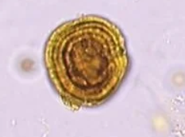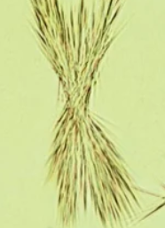
45
Figure 71 Leucine Crystal Figure 72 Tyrosine Crystal

Uric Acid - Rarely seen in urine from animals, this crystal takes on various forms but is most commonly seen as irregular rectangles (called “whetstones”), which can be flat or laminated, and may form rosettes. Other forms include ovals with pointed ends (“lemon”-shaped), barrels, cubes, “hammers”, six-sided forms resembling cystine and sheaves of thin long rectangles, among other unusual shapes. ₍₄₃₎
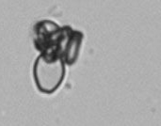
44
Figure 73 Uric Acid
Casts
46
Hyaline - They are usually colorless and low numbers of hyaline casts are usually insignificant and can be
seen in hyperthermic patients or post-exercise.
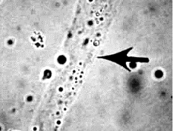
Figure 74 Hyaline Cast
Epithelial Cast - May be seen in cases of nephritis or pyelonephritis. See round to polygonal
epithelial cells fixed in a tubular arrangement. These cells
may undergo variable degrees of degeneration and develop a
granular appearance. The cellular or granular nature of the
cast gives an indication of how long the cast has been
present.
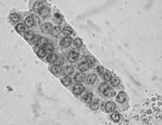
Figure 75 Epithelial Cast
Coarse Granular Cast - Seen initially when epithelial cell casts begin to degenerate. They are primarily an indicator of renal tubular damage. ⁽⁴⁶⁾
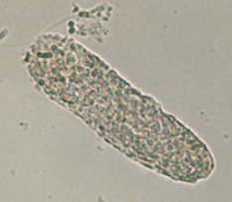
47
Figure 76 Coarse Granular Cast
Fine Granular Casts - Intermediate stage of degenerating cellular casts.This will eventually progress to waxy casts.
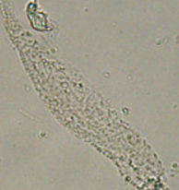
47
Figure 77 Fine Granular Cast
Waxy Casts - Homogeneous casts with sharp edges and possible cracks. Indicates a chronic tubular lesion. ⁽⁴⁶⁾
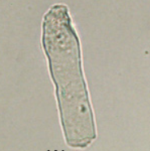
47
Figure 78 Waxy Cast
Fatty Casts - Fatty casts are identified by the presence of refractile lipid droplets within the protein matrix of the cast. The background matrix of the cast may be hyaline or granular in nature. Fatty casts, like granular casts, are thought to represent tubular degeneration. ₍₄₈₎
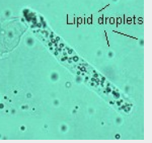
47
Figure 79 Fatty Cast
General interpretation: Casts are quantified for reporting as the number seen per low power field (10x objective) and classified as to type (e.g., waxy casts, 5-10/LPF). Casts in urine from normal individuals are few or none (and are usually hyaline or granular in nature). ⁽⁴⁸⁾
Parasitology

Preparing your direct fecal smear
- Place several drops of saline or fecal flotation solution on a slide with an equal amount of feces.
- Mix the solution and feces together with a wooden applicator until the solution is homogenous.
- Smear the solution over the slide into a thin film. The film should be thin enough to read print through.
- Remove any large pieces of feces.
- Place a coverslip over the smear.
- Examine the area of the slide under the coverslip with the compound microscope and record any protozoan cysts, eggs, larvae, or gross parasites seen. ⁽⁵⁰⁾

Preparing your fecal sediment
- Place about 2g if the fecal sample in a waxed paper cut. Add flotation medium and using a tongue depressor make an emulsion by thoroughly mixing the solution with the feces until your poop soup has been made.
- Pour the contents of the cup over a strainer into a second cup and wash strainer.
- Pour solution into a graduated cylinder and place in centrifuge with a counterbalance before starting.
- Centrifuge solution for three minutes (or depending on what the specific centrifuge recommends)
- See fecal float for final process

Preparing your fecal float
- Repeat steps above and finally remove tube after the centrifuge has stopped.
- Place tube in a test tube holder and fill the tube to the top with fecasol and cover with a coverslip.
- Let sit for ten minutes.
- Afterwards take coverslip off and place on microscope slide.
- Dump liquid portion into the sink but save the sediment portion.
- Using a pipette take a portion of the sediment of at the bottom and place on a microscope slide, and then cover with a coverslip.
- For both float & sediment view on low power.
- If nothing is seen on any part of the fecal exam it should be indicated with “no ova seen today”
- If parasites are seen it should be notated as 1+, 2+, 3+, 4+ followed by the ova or parasite seen.

Vaginal Cytology 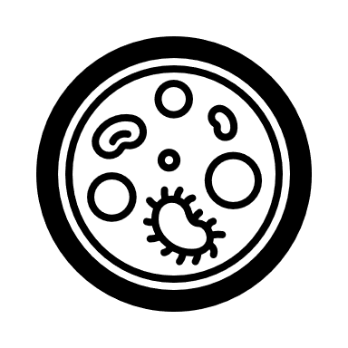
51
- Moisten a cotton-tipped swab with saline.
- Gently part the vulvar lips and insert the swab at the dorsal commissure of the vulva.
- Advance the swab dorsally and angle slightly cranially until the swab goes over the ischial arch, then advance slightly cranially.
- Gently roll the swab against the dorsal vaginal surface, then pull it straight out.
- Roll the swab on a glass slide, allow to air dry, and stain with Diff-Quick or Wright-Giemsa stain.
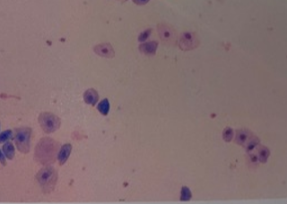
Figure 80 Proestrus in a bitch
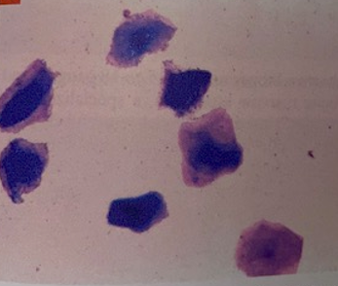
51
Figure 81 Estrus
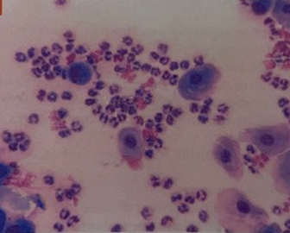
51
Figure 82 Diestrus
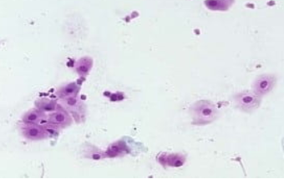
52
Figure 83 Anestrus
How to Gram Stain a slide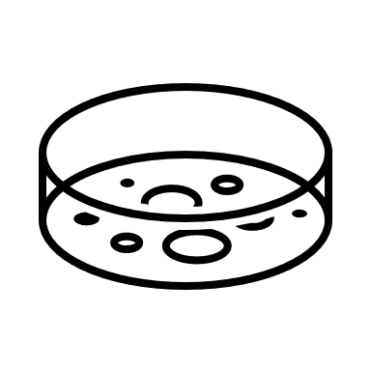

1. Place a loopful of tap water onto a slide. Touch a colony with a loop and mix the bacteria with the water until there is a uniform, thin film of microorganisms on the slide. DO SPREAD out the liquid as much as possible. Air dry sample

2. Heat fix the slide. Allow the slide to cool.

3. Stain with Crystal Violet for 1 minute by flooding the slide with stain. Rinse with water.

4. Apply Iodine solution for 1 minute by flooding the slide with iodine. Rinse with water.

5. CAREFULLY, decolorize for 3 seconds with Gram Stain Decolorizer by flooding the slide with decolorizer. IMMEDIATELY, rinse with water.

6. Counterstain with Safranin for 30 seconds by flooding the slide with stain. Rinse with water.

7. Dry the slide by putting it between the pages of a book of Bibulous paper. Remove slide and view organisms using the oil immersion objective of your microscope.

Ear Cytology
- Taking two cotton slip applicators place insert one into each ear being careful not to go to deep.
- After samples are collected break the left ear stick to differentiate between left and right ears.
- Gently rub swabs on a clean microscope slide and heat affix.
- Using diff-quick stain the slide for 30 seconds each and then rinse well.
- Allow slide time to dry before reading.
- Place slide on stage of microscope and focus up until you reach oil.
- Read results at that point
- If bacteria is seen it should be notated as 1+, 2+, 3+, 4+ followed by the bacteria seen.
- If no bacteria is seen it should be indicated with no significant findings documented.
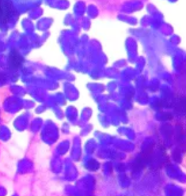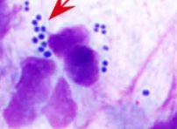
55
54
Figure 84 Yeast Figure 85 Cocci
References
- Normal Canine Erythrocytes. Normal canine erythrocytes. (n.d.). Retrieved March 23, 2023, from https://www.klimud.org/public/atlas/idrar/web/www.diaglab.vet.cornell.edu/clinpath/modules/rbcmorph/nk9.htm
- Harvey , J. (2017, April 25). The Feline Blood Film: 1. techniques and erythrocyte morphology. The feline blood film: 1. Techniques and erythrocyte morphology. Retrieved March 24, 2023, from https://journals.sagepub.com/doi/10.1177/1098612X17706466
- Normal leukocytes. eClinpath. (2019, November 30). Retrieved March 23, 2023, from https://eclinpath.com/hematology/morphologic-features/white-blood-cells/normal-leukocytes/
- Bassert, J. M., Beal, A. D., Samples, O. M., & McCurnin, D. M. (2022). McCurnin's clinical textbook for Veterinary Technicians and nurses. Elsevier.
- Sirois, M. (2020). Laboratory procedures for Veterinary technicians (Seventh). Elsevier.
- Acanthocytes. Cells and Smears. (2018, May 23). Retrieved March 25, 2023, from https://vetclinpathimages.com/2017/12/11/acanthocytes/
- Rouleaux. Cells and Smears. (2018, June 14). Retrieved March 25, 2023, from https://vetclinpathimages.com/2018/01/07/rouleaux/
- Agglutination. Cells and Smears. (2018, June 14). Retrieved March 25, 2023, from https://vetclinpathimages.com/2018/01/07/agglutination/
- Polychromasia. MedSchool. (n.d.). Retrieved March 25, 2023, from https://medschool.co/test-findings/polychromasia
- Boonyong, R. (n.d.). Red Blood Cell Morphology. hemoglobin distribution of red blood cell. iStock. Retrieved March 25, 2023, from https://www.istockphoto.com/vector/red-blood-cell-morphology-hemoglobin-distribution-of-red-blood-cell-gm1393635071-449407756
- Aird, W. (2022, May 11). Schistocytes • the blood project. The Blood Project. Retrieved March 25, 2023, from https://www.thebloodproject.com/schistocytes/
- Sharkey, L., & Heinrich, D. (2022, February 18). In-clinic hematology: The blood film review. Today's Veterinary Practice. Retrieved March 27, 2023, from https://todaysveterinarypractice.com/hematology/in-clinic-hematology-the-blood-film-review/
- Shape changes. eClinpath. (2022, July 15). Retrieved March 27, 2023, from Howell-jolly bodies from a splenectomized dog. eClinpath. (n.d.). Retrieved March 27, 2023, from https://eclinpath.com/hematology/morphologic-features/red-blood-cells/rbc-inclusions/howell-jolly-bodies-from-a-splenectomized-dog/ Hypochromasia. Cells and Smears. (2018, May 23). Retrieved March 27, 2023, from https://vetclinpathimages.com/2018/03/26/hypochromasia/
- RBC morphology. eClinpath. (2020, June 12). Retrieved March 27, 2023, from https://eclinpath.com/atlas/hematology/rbc-morphology/
- Pin auf hematology. Pinterest. (2017, June 9). Retrieved March 27, 2023, from hHowell-jolly bodies from a splenectomized dog. eClinpath. (n.d.). Retrieved March 27, 2023, from https://eclinpath.com/hematology/morphologic-features/red-blood-cells/rbc-inclusions/howell-jolly-bodies-from-a-splenectomized-dog/ ttps://id.pinterest.com/pin/539095017885712560/
- Howell-jolly bodies from a splenectomized dog. eClinpath. (n.d.). Retrieved March 27, 2023, from https://eclinpath.com/hematology/morphologic-features/red-blood-cells/rbc-inHowell-jolly bodies from a splenectomized dog. eClinpath. (n.d.). Retrieved March 27, 2023, from https://eclinpath.com/hematology/morphologic-features/red-blood-cells/rbc-inclusions/howell-jolly-bodies-from-a-splenectomized-dog/ clusions/howell-jolly-bodies-from-a-splenectomized-dog/
- Berger, S. (2017, October 4). Idexx Diagnostic Challenge: Why is angel anemic?: Anemic dog: Idexx challenge: Anemia after surgery in a dog. MedVet. Retrieved March 27, 2023, from https://www.medvetforpets.com/idexx-diagnostic-challenge-angel-anemic/
- Normal platelets. eClinpath. (2014, June 25). Retrieved March 30, 2023, from https://eclinpath.com/hematology/morphologic-features/platelets/normal-pNormal platelets. eClinpath. (2014, June 25). Retrieved March 30, 2023, from https://eclinpath.com/hematology/morphologic-features/platelets/normal-platelets/ latelets/
- Red Blood Cells. eClinpath. (2016, February 3). Retrieved March 30, 2023, from https://eclinpath.com/hematology/morphologic-features/red-blood-cRed Blood Cells. eClinpath. (2016, February 3). Retrieved March 30, 2023, from https://eclinpath.com/hematology/morphologic-features/red-blood-cells/ ells/
- Avian WBC. eClinpath. (2020, August 19). Retrieved March 30, 2023, from https://eclinpath.com/atlas/avian-hematology/avian-wbc/
- Avian RBC. eClinpath. (2020, August 19). Retrieved March 30, 2023, from https://eclinpath.com/atlas/avian-hematology/avian-rbc/
- Diagnostic Hematology of Reptiles - seaturtle.org. Diagnostic Hematology of Reptiles. (n.d.). Retrieved March 31, 2023, from http://www.seaturtle.org/PDF/StacyNI_2011_ClinLabMed.pdf
- Toxic change. eClinpath. (2021, September 26). Retrieved March 31, 2023, from https://eclinpath.com/hematology/morphologic-features/white-blood-cells/toxic-change/
- Left shift. eClinpath. (2016, October 27). Retrieved March 31, 2023, from https://eclinpath.com/hematology/morphologic-features/white-blood-cells/left-shift/
- Jorge, Psaradaki, C., Brigette, Anderson, E., Diana, & Camilla. (2022, November 23). Spilling the secrets of counting cells with a hemocytometer. ChemoMetec. Retrieved March 31, 2023, from https://chemometec.com/how-to-count-cells-with-a-hemocytometer/
- PetMD Editorial. (2011, March 16). Reading the Blood Chemistry Panel: An art and science. PetMD. Retrieved March 31, 2023, from https://www.petmd.com/dog/general-health/evr_dg_reading_the_blood_chemistry_panel
- Chemistry (cobas). Cornell University College of Veterinary Medicine. (2019, May 7). Retrieved April 1, 2023, from https://www.vet.cornell.edu/animal-health-diagnostic-center/laboratories/clinical-pathology/reference-intervals/chemistry
- Allison, R. (n.d.). Image: Mycoplasma haemocanis infection, Canine Blood Smear. Merck Veterinary Manual. Retrieved April 1, 2023, from https://www.merckvetmanual.com/multimedia/image/mycoplasma-haemocanis-infection-canine-blood-smear
- Mycoplasma. eClinpath. (2021, June 13). Retrieved April 1, 2023, from https://eclinpath.com/hematology/infectious-agents/mycoplasma/
- Babesia/theileria. eClinpath. (2022, January 9). Retrieved April 1, 2023, from https://eclinpath.com/hematology/infectious-agents/babesia/
- Babesia. Cells and Smears. (2018, July 10). Retrieved April 1, 2023, from https://vetclinpathimages.com/2018/01/08/babesia/
- Alvarez, J. A., Rojas, C., & Figueroa, J. V. (2020, May 26). An overview of current knowledge on in vitro Babesia cultivation for production of live attenuated vaccines for bovine babesiosis in Mexico. Frontiers. Retrieved April 1, 2023, from https://www.frontiersin.org/articles/10.3389/fvets.2020.00364/full
- Cytauxzoon. eClinpath. (2021, July 30). Retrieved April 1, 2023, from https://eclinpath.com/hematology/infectious-agents/cytauxzoon/
- Infectious agents. eClinpath. (2014, June 25). Retrieved April 1, 2023, from https://eclinpath.com/exotics/hematology-exotics/infectious-agents/
- Anaplasma. eClinpath. (2016, April 3). Retrieved April 1, 2023, from https://eclinpath.com/hematology/infectious-agents/anasplasma/
- Ehrlichia. eClinpath. (2023, February 13). Retrieved April 1, 2023, from https://eclinpath.com/hematology/infectious-agents/ehrlichia/
- Pfeifer, M. (2022, February 12). Ehrlichia canis discovered in dog. Texas A&M Veterinary Medical Diagnostic Laboratory. Retrieved April 1, 2023, from https://tvmdl.tamu.edu/2019/10/01/ehrlichia-canis-discovered-in-dog/
- Atkins, C. E. (2023, March 22). Heartworm disease in dogs, cats, and ferrets - circulatory system. Merck Veterinary Manual. Retrieved April 1, 2023, from https://www.merckvetmanual.com/veterinary/circulatory-system/heartworm-disease/heartworm-disease-in-dogs,-cats,-and-ferrets#v54966471
- Szatmári, V., van Leeuwen, M. W., Piek, C. J., & Venco, L. (2020, October 1). False positive antigen test for dirofilaria immitis after heat treatment of the blood sample in a microfilaremic dog infected with Acanthocheilonema dracunculoides - parasites & vectors. BioMed Central. Retrieved April 1, 2023, from https://parasitesandvectors.biomedcentral.com/articles/10.1186/s13071-020-04376-9
- Chemical constituents. eClinpath. (2023, February 12). Retrieved April 1, 2023, from https://eclinpath.com/urinalysis/chemical-constituents/#protein-dipstick
- Rogers, J., Cadogan, M., & Cadogan, J. R. and M. (2023, February 28). Dipstick urinalysis. Life in the Fast Lane • LITFL. Retrieved April 1, 2023, from https://litfl.com/dipstick-urinalysis/
- Transitional epithelial cell. eClinpath. (n.d.). Retrieved April 1, 2023, from https://eclinpath.com/urinalysis/cellular-constituents/transitional-epithelial-cell-2/
- Cellular constituents. eClinpath. (2022, March 5). Retrieved April 1, 2023, from https://eclinpath.com/urinalysis/cellular-constituents/
- Understand your sedivue DX results. Understanding SediVue urinalysis results - IDEXX US. (n.d.). Retrieved April 1, 2023, from https://www.idexx.com/en/veterinary/analyzers/sedivue-dx-analyzer/sedivue-resource-center/sedivue-results/
- Aryal, S., Patrick, O., Matthews, T., & Hayat, A. (2022, September 17). Types of crystals in urine. Microbe Notes. Retrieved April 1, 2023, from https://microbenotes.com/types-of-crystals-in-urine/
- Illinois State Veterinary Medical Association. (n.d.). Retrieved April 2, 2023, from https://www.isvma.org/wp-content/uploads/2017/10/Urinalysis_made_easy_The_Complete_Urinalysis.pdf
- Cast compilation. eClinpath. (n.d.). Retrieved April 1, 2023, from https://eclinpath.com/urinalysis/casts/cast-compilation/
- Casts. eClinpath. (2022, March 5). Retrieved April 1, 2023, from https://eclinpath.com/urinalysis/casts/
- Infectious agents. eClinpath. (2014, July 10). Retrieved April 2, 2023, from https://eclinpath.com/urinalysis/infectious-agents/
- Hendrix, C. M., & Robinson, E. (2017). Diagnostic Parasitology for Veterinary technicians (5th ed.). Elsevier.
- Taylor, S. M. (2021). Small animal clinical techniques (3rd ed.). Elsevier.
- Image: Vaginal cytology typical of anestrus, dog. Merck Veterinary Manual. (n.d.). Retrieved April 2, 2023, from https://www.merckvetmanual.com/multimedia/image/vaginal-cytology-typical-of-anestrus-dog
- Instructions: Gram stain. (n.d.). Retrieved April 2, 2023, from https://www.atsu.edu/faculty/chamberlain/Website/lab/idlab/gramst.htm
- Ear Swabs: Technique & interpretation. Clinician's Brief. (n.d.). Retrieved April 2, 2023, from https://www.cliniciansbrief.com/article/ear-swabs-technique-interpretation
- Image gallery: Ear cytology. Clinician's Brief. (n.d.). Retrieved April 2, 2023, from https://www.cliniciansbrief.com/content/image-gallery-ear-cytology
- VTEC 1240 Laboratory Animal and Exotics, Meri Kosman

Index

Blood
Canine…………………..pg. 4
Feline……………………pg. 8
Abnormal morph………. pg. 10
Toxic change……………pg. 20
Large animal……………pg. 24
Exotic & avian ………… pg. 31
Math……………………..pg. 37
Hemocytometer………….pg. 39
Tests…….……………….pg. 43
Electrolytes………………pg. 44
Blood Parasites…………..pg. 47
Urine
Urinalysis………………pg. 64
Dipstick………………..pg. 66
Sediment……………….pg. 70
Crystals…………………pg. 78
Parasitology
Fecal…………………..pg. 90
Miscellaneous
Vaginal cytology……….pg. 93
Gram stain……………..pg. 95
Ear cytology……………pg. 96
References…………….pg. 97

